Augustus Mendy

Southern New Hampshire University

CS-499-10450-M01

Professor Ramsey

September 7, 2025

**1-2 Module One Assignment**

In order to complete the ePortfolio, I will first use this paper to showcase my abilities in three important computer science domains: databases, algorithms and data structures, and software design/engineering. It talks on the work and improvements that have been suggested (Southern New Hampshire University, 2025).

Two artifacts have been chosen for each category of the final project, ePortfolio, which represents my development in the crucial areas of databases, algorithms and data structures, and software design/engineering. Projects from computer science program classes make up the selected artifacts. Although my abilities in the mentioned key category are demonstrated by the chosen artifact, the artifacts may also show abilities in other important categories.

**“Software**: Design and Engineering”

**“Artifact:** Inventory App – Android Mobile App”

**“Origin:** CS360 Mobile Architect and Programming”

**Enhancement plan:**

My inability to add more than one item to the ItemActivity list when delivering the finished product limits the app's ability to function as intended. I aim to make the app completely functional by enhancing the ItemActivity list's design and login features, as well as the software engineering by including the option to add things, modify their quantities, remove an item, or remove every item in the database. If a user forgets their password, I will make the login activity better by adding the opportunity to restore it.

**Skills:**

By improving the functionality of the app, I will demonstrate the abilities acquired in software design and development for optimizing a mobile app. In order to create, read, update, and remove records from a database, we can use the Android Studio IDE tool in conjunction with the SQLite database and the Java programming language. Exhibit the ability to move information between tasks, activate mobile device features, and clearly understand the relationships and integration of the components in a source code of functions.

**Outcomes:**

“[CS-499-03]” While managing the trade-offs associated with design decisions, create and assess computational solutions that address a particular problem utilizing algorithmic concepts, computer science methods, and standards relevant to its resolution.

“[CS-499-04]” Exhibit the capacity to apply sound and creative methods, abilities, and resources in computing practices to integrate computer solutions that add value and achieve objectives unique to a given industry.

**Pseudocode:**

1. Make the database CRUD code more functional.
2. Make it possible to retrieve user passwords from the login screen.
3. Enhance the source code functionality to make it easier to manage and list the database's contents.

**“Algorithm and Data Structures”**

“**Artifact:** Authentication and Monitoring System”

**“Origin:** IT145 Foundation in Application Development”

**Enhancement plan:**

My goal is to increase the application's functionality by including a dashboard (monitoring system). The dashboard will carry out tasks based on user authorization and authentication in order to track the activities of the animals under its care and keep an eye on their living environments. Include the ability to read user input and use system output. uses standard libraries and the proper control structures for program logic to bring in preset functionality using the Java programming language and run in the terminal console. Break the program in the appropriate classes and make use of all the methods that are included in the classes.

**Skills:**

In order to successfully incorporate key components of object-oriented programming, the upgrade will show our comprehension of algorithm logic and its relationship to data structures. Create simple, functional applications that successfully integrate essential elements of object-oriented programming by demonstrating the ability to use and maintain Java programming source codes. To create successful programs, implement the proper variables, operators, methods, and classes that are utilized in object-oriented programming. Describe the appropriate rules and syntax in terms of programming best practices. The process of testing existing code, finding mistakes, and fixing them to improve functionality is known as debugging.

**Outcomes:**

“[CS-499-01] “Use techniques for creating cooperative settings that allow a range of audiences to assist in computational science decision-making within organizations.

“[CS-499-05]” Adopt a security mindset that foresees hostile exploits in software architecture and designs in order to identify possible weaknesses, address design flaws, and guarantee privacy and improved data and resource security.

**Pseudocode:**

1. Make use of the proper control structures for program logic.
2. Create and present a basic terminal GUI dashboard.
3. Depending on user authorization and authentication, display several screens.

**Databases:**

**“Artifact**: Salvare Search for Rescue App”

**“Origin:** CS340 Client/Server Development”

**Enhancement plan:**

Apporto was used in the development of this project. I will enhance the dashboard GUI and replicate the application on my local computer. After testing the dashboard locally, I will improve the appropriate implementation guidelines.

Skills:

By using the Python framework Dash and implementing and utilizing the PyMongo driver, we can demonstrate our proficiency with the Python language and the integration of MongoDB databases. Create, execute, and test Python scripts by demonstrating how to use and manage Jupiter Notebook.

**Outcomes:**

“[CS-499-03]” Using algorithmic principles, computer science methods, and standards relevant to the problem's solution, build and assess computational solutions that address it while controlling the trade-offs associated with design decisions.

“[CS-499-04]” Exhibit the capacity to apply sound and creative methods, abilities, and resources in computing practices to integrate computer solutions that add value and achieve objectives unique to a given industry.

**Pseudocode:**

1. To enhance the dashboard's performance in various computer environments, update the documentation.
2. Describe the application's development process using the software pattern.

**ePortofolio Overall:**

In order to lower security risks and avoid delaying security till the very end of the software development life cycle, I intend to demonstrate how to create a secure coding standard from the beginning in an engaging manner through the code review of an artifact. The likelihood of creating vulnerabilities increases with the complexity of the application. Therefore, it is necessary to modify the structure, style, logic, performance, test coverage, design, readability and maintainability, and functionality of all software development processes. To assess structure and functionality, some of these can be automated using third-party tools, while others need human assessment. Focusing on the correct topics might be aided by going over code with targeted queries. We will look for the correct things while keeping questions in mind by critically analyzing code. In addition, we'll cut down on testing time.

Through the stories of the categories of databases, algorithms and data structures, and software design and engineering, I hope to demonstrate the abilities and knowledge gained by using suitable data structures for efficiently organizing data given the demands and limitations of different problems. In order to create efficient computer programs, use fundamental algorithms and shared data structures, and implement technically sound algorithms that precisely carry out necessary tasks. using suitable organizational strategies to monitor software development projects' progress and to ensure that software and systems services are developed using security practices and methodologies from the start. When feasible, divide the program into smaller methods to meet the requirements of every code block. Then, apply security measures by correcting the behavior of the methods. Put quality assurance methods into practice that are successful in locating and removing vulnerabilities. The quality assurance method should include testing and source code audits.

I will demonstrate our history and reasons for enrolling in a computer science program in order to maintain and enhance the information and abilities we have gained over the years of study in the professional self-assessment. Through the portfolio, highlight our special skills and aptitudes, which are centered on high motivation, well-organized, and successful mastery of the various planning and programming tools and components in an SDLC, as well as our ability to integrate those components to navigate the field in an agile environment. putting knowledge of several programming languages, such as C++, Java, Python, SQL, and development and integrated development tools (IDEs), to use in order to foster a culture of collaboration and provide innovative, creative solutions for the built environment. During coding, debugging, and troubleshooting, show off our innate ability to solve logical problems in order to apply industry best practices and standards. I actually look forward to succeeding and challenging myself, and I enjoy taking up new talents and gaining them rapidly.

“Webpage wireframe”

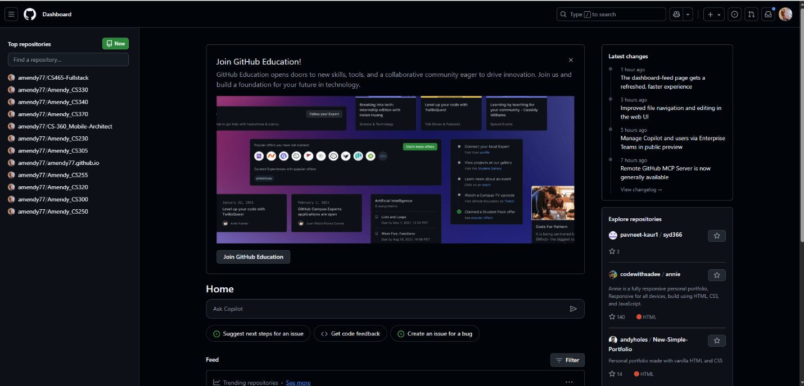

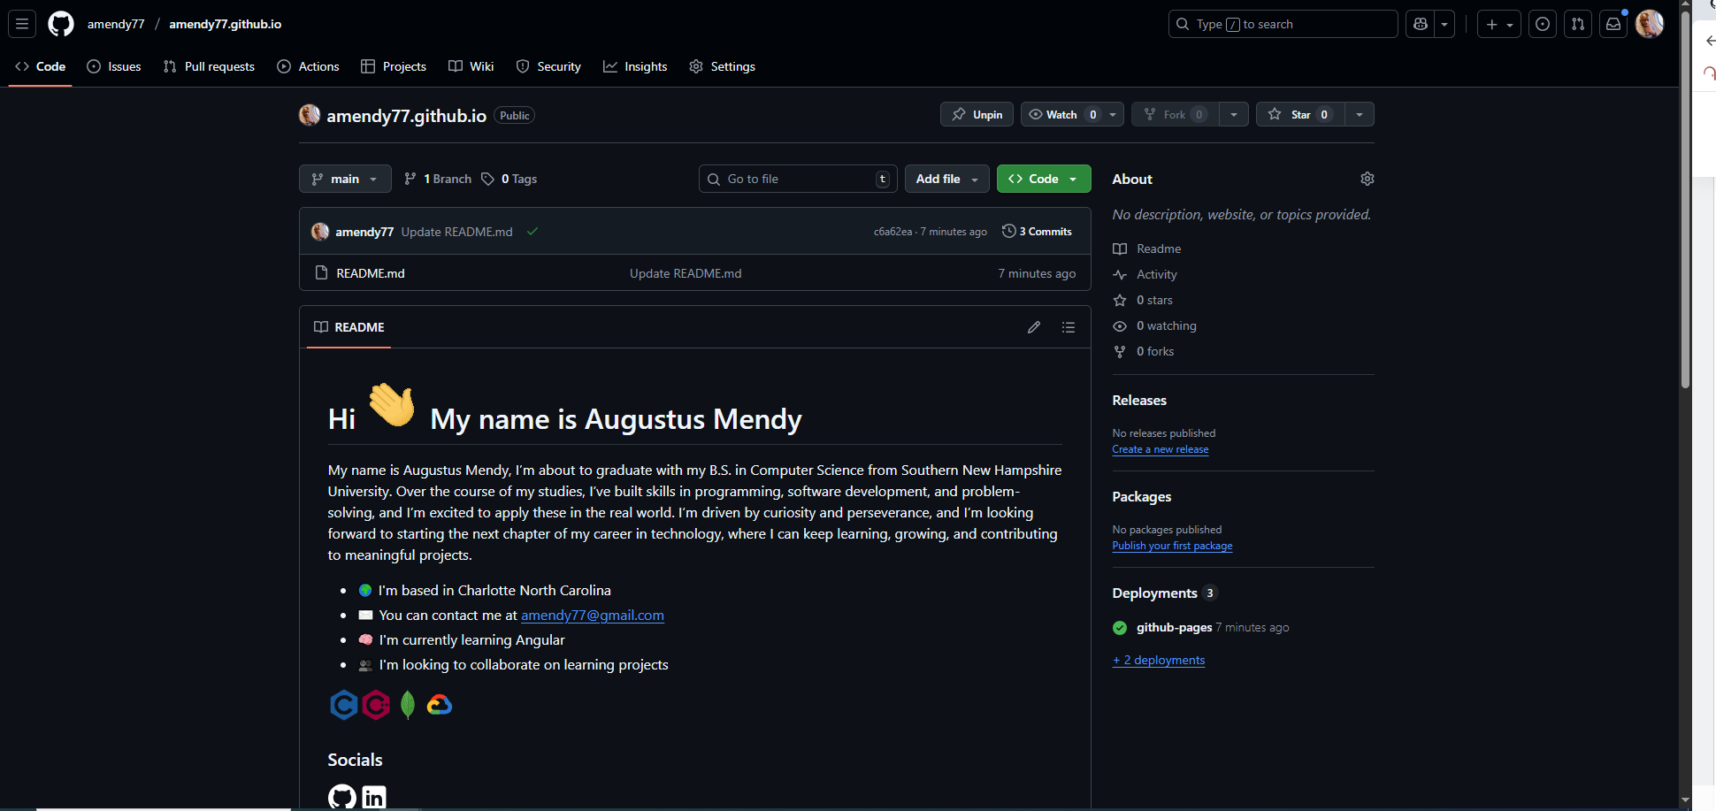

For the final ePortfolio webpage, I'm thinking of using the structure shown below, in which the code review area and each important category will have an image title. I anticipate creating a page with a similar structure for every artifact on the main categories, along with a brief description and a screenshot of the artifact in use. The introduction, code review, and important categories will be at the top of the page, followed by the self-assessment at the bottom.

References

“<https://learn.snhu.edu/d2l/le/content/2019772/viewContent/43178988/View>.

<https://youtu.be/aNRsKGf11Oo?si=PnCRZHf4lytagdmZ>.”

“Retrieved from Module One: Introduction: Portfolios, Supporting Tools, and Keeping Pace: <https://learn.snhu.edu/d2l/le/content/1014915/viewContent/17247445/View>.”